WHPS Green Bay/Door County Bus Trip - Wednesday-Friday, September 12-14, 2018
Tour Leader: Jane Gahlman, Ph: 608-837-2317; Cell: 608-575-6630; email: jmgahlman@hotmail.com
Departure time: 7:30 am on Wednesday, September 12, from Shopko South Towne parking lot
Alternate Pick-up Point at Planeview Travel Plaza: 9:00 am on Wednesday, September 12
Alternate Drop-off Point at Planeview Travel Plaza: 4:30 pm on Friday, September 14
Return time: approximately 6:15 pm on Friday, September 14 at Shopko South Towne
What’s included: bus, driver tip, two night stay at hotel with continental breakfast on Thursday, September 13 and Friday, September 14, entry to all public and private gardens, lunch at Al Johnson’s Restaurant on Thursday, September 13.
What’s not included: Lunch on Wednesday, September 12 is on your own – Please bring a sack lunch to eat on the bus. Lunch on Friday, September 14 is on your own in Fish Creek. Dinner on Wednesday, September 12 and Thursday, September 13 is on your own in Sturgeon Bay. There will be NO water or beverages on the bus—please plan accordingly and bring your own refillable water bottle or beverage for the trip.
Cost: $285/person; no single supplement
Deadline to sign-up: July 10, 2018 (No refunds after July 10, 2018)
Highlights: On this three day bus trip to the Green Bay/Door County area we will visit three public gardens, six private gardens, four garden centers, a gallery and a farm market. (Actual schedule subject to change. Final itinerary will be sent to participants after July 10, 2018.)

Hotel
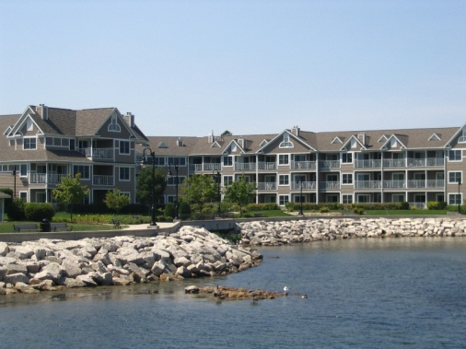
Bridgeport Waterfront Resort, 50 W Larch St, Sturgeon Bay, WI 54235 Ph: 800-671-9190; http://www.bridgeportresort.net
Bridgeport Waterfront Resort is located in the center of historic Sturgeon Bay with exceptional access to all of Door County, Wisconsin's quaint shops, award winning restaurants, scenic parks and wide variety of attractions. Every modern convenience you would expect to find at home is found within the comfort of your suite. Bridgeport's suites each feature a fireplace and a complete kitchen. The experience is complimented by on-site recreation including heated swimming pools, a whirlpool, a sauna, a fitness center and high-speed wireless internet.

Public Gardens
Green Bay Botanic Garden, 2600 Larsen Rd, Green Bay, WI Ph: 920-490-9457; www.gbbg.org
Rooted in Community, Green Bay Botanical Garden is a 100% community supported non-profit that connects people with plants in an environment that engages, inspires and refreshes. Open all year, Green Bay Botanical Garden is designed to provide interest with display gardens that capture the beauty of northeastern Wisconsin’s four distinct and wonderful seasons. Learn about the vital role plants play in our lives and enjoy spending time with family and friends. Be refreshed by gardens overflowing with beauty and serenity.

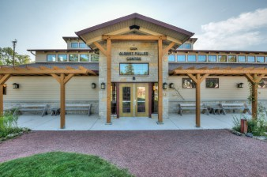
The Ridges Sanctuary, 8166 WI-57, Baileys Harbor, WI 54202 Ph: 920-839-2802; http://www.ridgessanctuary.org
In 1937, The Ridges Sanctuary became Wisconsin’s first land trust. For 80 years, it has been an integral part of the rich, natural setting of the Baileys Harbor community and the Door County Peninsula. Founded to preserve the original 30 acre parcel, The Ridges has grown thoughtfully and strategically to ensure the protection of the most biologically diverse ecosystem in Wisconsin. Today, with the support of over 1700 members in all 50 states and the District of Columbia, and the hard work of our staff and more than 200 committed volunteers, The Ridges permanently protects over 1600 acres of the most critical lands in our community. The Sanctuary is named for its distinctive topography – a series of 30 ridges and swales formed by the movement of Lake Michigan over the past 1400 years. This ridge-swale complex provides a wide range of environmental conditions, from open beach to densely shaded conifer forest. Nearly 500 different species of plants, including 25 species of native orchids, populate these varied habitats which are also home to over 60 species of breeding birds and 12 threatened or endangered species, including the federally endangered Hine’s Emerald dragonfly. Each year, we welcome thousands of visitors to these pristine acres where orchids continue to thrive along trails and boardwalks much as they did when these paths were first cleared by our founding members in 1938.
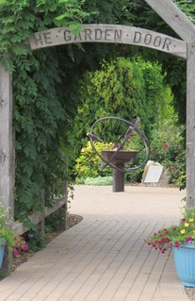
The Garden Door MG garden, 4312 Hwy 42 N, Sturgeon Bay, WI http://www.dcmga.org/the-garden-door.html
The Garden Door was created in 2004 at the University of Wisconsin Peninsular Agricultural Research Station which is a few miles north of Sturgeon Bay on Highway 42. The garden is designed and maintained by members of the Door County Master Gardeners Association. It has a fairie garden, double kaleidoscope, pond with koi, a children's play area, butterfly garden, wind and sound tunnel, ornamental grasses area with bottle trees, fences, annual and perennial beds. To the north you will find a community garden where the Door County Master Gardener Volunteers and research/extension office personnel can plant and harvest crops each summer.

Private Gardens
Herb and Gladys King private garden, 2440 Hillside Lane, Green Bay, WI
Our woodland gardens are ever changing… a work in progress. They are tucked in to a wooded area on a large city lot. The gardens envelop the front and back of the house using the natural flow of the land to its best advantage. Being “hooked” on hostas since the early 90’s, Herb has been hybridizing for over 20 years. More than 400 of our hostas are named while hundreds more are still under evaluation. These are mixed with more than 550 commercial varieties and planted amidst astilbe, ferns and other colorful accent plants. Paths wind throughout the gardens passing over a babbling stream flowing into a pond, under arbors and around pavilions, passing fountains and garden statuary along the way. An elevated deck stretches across the back of the house offering not only a perfect view of the pond and gardens, but providing a backdrop for vines and container plantings. We virtually live in our gardens as playing in the “yarden” is our favorite pastime. It keeps us young at heart!!
Karin Overbeck private garden, 5338 County TT, Sturgeon Bay, WI
My garden has never been about the plants. It is an experiment in recycling, mosaics and happiness. Recently I’ve reduced the size - more lawn and vegetables. And yes, I do it all myself. ~Karin Overbeck
Cajun Acres private garden, 5807 West Townline Rd, Sturgeon Bay, WI

Welcome! To gardens with whimsy... from koi ponds to a lotus bog... from llamas to camels! Polish chickens to emu...... tropical plants on the deck, and some unusual topiaries.... our gardens and animals are sure to be memorable... we hope you enjoy what we call home. ~Lisa and Ken Jeansonne of Cajun acres.

The Inn at Windmill Farm, 3829 Fairview Road, Baileys Harbor, Wisconsin 54202 Ph: 920-868-9282 www.1900WindmillFarm.com
The home dates to the early 1900s and was built in the Dutch style. Until recently, it had been a true working Wisconsin farm. The barns and silo remain as well as the windmill and well house. The Inn lends itself well to creativity—painting, writing, contemplation. Ed has been an artist for over 35 years. He teaches at the Kansas City Art Institute as a visiting faculty member and teaches several workshops in the United States, Mexico and Europe each year. Ed’s work can be seen at Windmill Farm in the Morning Mist Studio/Gallery in the historic barn. Ed’s work has been in many national shows and was named Door County Master Artist of the Year in 2008. Now a permanent resident of Door County, he offers classes in his studio at Windmill Farm. Take a moment to visit Ed’s Watercolor Excitement web site. Frank has a great background in fine antiques and has great pieces for sale at Lupine Antiques at Windmill Farm in the historic barn. In addition, he brings to the Inn an extensive knowledge of landscape design. Take in the pastoral vistas and remind yourself where you are. Quiet, tranquil, beautiful, and nostalgic…this is Windmill Farm.

William & Sunshine Walker private garden, 11977 Bay Ln, Ellison Bay, WI 54210
“All because two people fell in love” reads the sign on the front of the house. This will be our 13th year in Ellison Bay and each year we have worked on improving the grounds ... 13 gardens including hundreds of hostas, zen raking garden, koi pond, goldfish pond, frog pond, waterfalls, windchime gazebo, 5 pagodas and countless other features large and small – most with an Asian motif and an abundance of whimsy. There are a number of ceramic wall pieces by local artists. We have also done all we could to incorporate native stone masonry. We are two people who prove that while you might grow old, growing up is only an option.
Kate Klass and Steve Rhodes private garden, 4439 Valhalla Road, New Franken, WI
Garden Centers/Nurseries
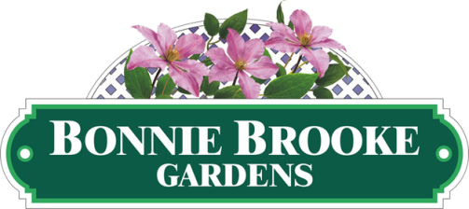
Bonnie Brooke Gardens, 337 N. 14th Avenue, Sturgeon Bay, WI 54234 Ph: 920-743-9794; http://bonniebrookegardens.com
We are a locally-owned independent garden center and greenhouse. For more than 30 years we have been offering top quality plants to the area of Sturgeon Bay, Door County and beyond. Our friendly staff is educated in horticulture and they are experienced gardeners. We are happy to share our expertise with new gardeners as well as green thumbs for success in any gardening adventure. We grow most of the plants that we sell right here in our greenhouses so that we can offer a unique selection of fresh, healthy plants. Plants that are grown locally are better adapted to our local environment. The assortment of plants will change seasonally. We nurture our plants with great care so that they may flourish when they find a home with you. We offer varieties of perennials and northern-grown nursery stock that are hardy for our growing zone. The shop is where you will find gardening supplies, pottery, garden décor and more.
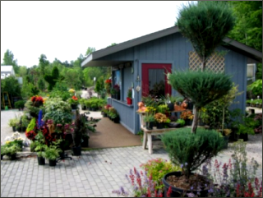
Briggsville Gardens, 3273 Mathey Rd, Sturgeon Bay, WI 54235 Ph: 920-743-1246; http://www.briggsvillegardens.com
The evolution of Briggsville Gardens has thrived since its' creation in 1990 by both Richard and Tammy Briggs. Their dreams have transformed into a tangible vibrant business that will continue to contribute to the inner beauty of Door County. Armed with a green thumb, horticulture degree and a distinct vision of creativity, Richard Briggs will utilize his knowledge and experience to turn your visions to reality.

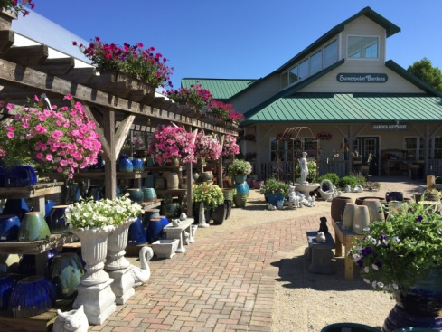
Sunnypoint Gardens, 6939 WI-42, Egg Harbor, WI 54209 Ph: 920-868-3646; http://www.sunnypointdoorcounty.com
Whether you're a seasonal or year-round Door County resident, or one of the county's many visitors, Sunnypoint Gardens is a favorite Door County destination for gardeners! Stroll the garden center's many aisles and see "What's NEW" for 2018! Find an excellent selection of garden favorites plus the newest plant varieties of annuals, perennials and edibles. Gorgeous hanging baskets & colorful combination patio planters are perfect for an instant garden and that "WOW" factor for decks or patios. Choose from a variety of gorgeous plant options for your gardens & landscapes in our nursery department. Sunnypoint features Door County's largest selection of colorful roses and hydrangeas, plus an exceptional selection of unique and favorite varieties of shrubs, evergreens, and trees. Sunnypoint's Garden Gift Shop offers a large selection of garden décor items, plus gardening supplies and a wide variety of products for proper plant care & health. Colorful pottery in all shapes and sizes, statuary, garden benches, metal garden art, fairy gardening accessories, birdbaths and birdfeeders are just a few of the many items Sunnypoint features for gardeners to personalize their garden spaces!
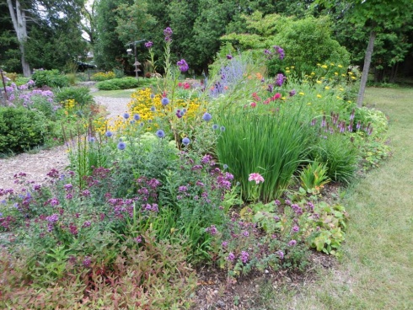
Handverks Gardens & Studio, 10059 State Hwy 57, Sister Bay, WI 54234 Ph: 920 421-2985; https://handverksmusic.com/garden-nursery
At Handverks Gardens we enjoy sharing our love of gardening with all who stop to visit. We provide friendly, knowledgeable advice as we help you find the right plants for your specific gardening needs. We practice sustainable garden principles by not using pesticides or synthetic fertilizers; instead we use compost on all of our gardens. While we promote the use of native plants, favorite garden perennials planted along side them create cottage gardens full of color, texture, depth and form. A variety of handcrafted gift items designed and created by Grace Bernhard such as jewelry, cozy infinity neck scarves, felted soap, glass mosaics and wood carvings, many one-of-a-kind can be found here.

Restaurants
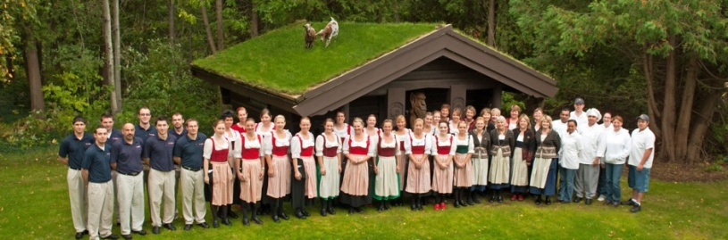
Al Johnson’s Swedish Restaurant, 10698 N Bay Shore Dr, Sister Bay, WI 54234 Ph: 920-854-2626; http://www.aljohnsons.com/our-story
An icon for visitors for over 58 years, Al Johnson’s is an authentic Swedish family owned restaurant where you can find goats grazing the sod roof. It's quite a sight, and it's made this place one of the most famous restaurants in Door County. Inside the casual, carpeted dining room, young ladies in Scandinavian garb dish out limpa bread and Swedish meatballs. The food is served on dishes from Porsgrund, Norway, the decorative rosemaled painting around the interior was done by renowned Norwegian artist Sigmund Arseth. Many of the foods served are Swedish and Norwegian. Anything from the Swedish pancakes and meatballs served with Swedish lingonberries (a small, red berry much like a cranberry or currant in taste) to the varied Swedish crackers and Limpa bread on the bread tray, to the many specialty cheeses from Sweden, there is much to delight the palate!
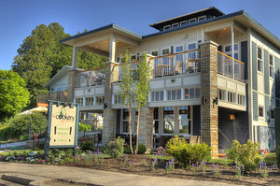
The Cookery Restaurant, 4135 Main St Hwy 42, Fish Creek, WI 54212 Ph: 920-868-3634; http://www.cookeryfishcreek.com http://www.cookeryfishcreek.com/menu/#menus
The Cookery is a family run restaurant established in 1977. Offering American casual fare with an emphasis on local ingredients. all menu items are made from start to finish in our kitchen. Breakfast, lunch, and dinner are served daily. We also have a nice selection of vegetarian entrees, gluten free items, and an innovative kids' menu. our second level Wine Bar offers a view of the fish creek harbor, features happy hours daily and live music weekly. We look forward to having you dine with us.
Gallery/Farm Market/Truck Stop
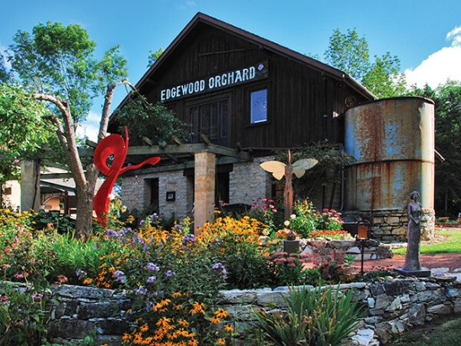
Edgewood Orchard Galleries, 4140 Peninsula Players Rd, Fish Creek, WI 54212 Ph: 920-868-3579; https://edgewoodorchard.com
Edgewood Orchard Galleries is one of the Midwest’s most respected art galleries, known since 1969 for its exhibitions exploring ideas in a wide range of media. Paintings, sculpture, glass, clay, wood and jewelry are all represented. Open daily from May through November, the gallery presents monthly changing feature shows, along with its general exhibits of work by over 150 artists. Although many of these artists are of national reputation, the atmosphere is welcoming and creative, with a genuine love of art and people felt throughout. The setting is as exceptional as the artwork shown. Housed in a stone fruit barn built in 1918 and located on an 80 acre orchard, the gallery has been lovingly restored and enhanced by owner-architect Minnow Emerson. It includes a bricked courtyard with bistro tables and chairs, a glassed portico, a sculpture garden, fine leaded-glass windows and the beauty of nature outside every window. The gallery was started by artist Irene Haberland and her daughter Anne and and is now owned by Anne and Minnow’s daughter and son-in-law Nell Emerson Jarosh and her husband J.R. Nell grew up surrounded by art and the artists who create it, and Nell and J.R. are now happy to offer the same opportunity to their daughters.
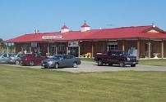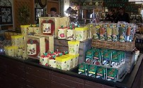
Wood Orchard Market, 8112 State Highway 42, Egg Harbor, WI Ph: 920-868-2334/866-763-2334; http://www.woodorchard.com
Wood Orchard and Wood Orchard Market is a family owned fruit farm in beautiful Door County, Wisconsin. Jim and Barbara Wood established the orchard in 1955 after moving their young family to cool Door County from hot and humid St. Louis, Missouri. With the help of many wonderful people working together, Wood Orchard Market brings you a TRULY UNIQUE, TOTALLY DELICIOUS, and VERY DOOR COUNTY shopping experience. Wood Orchard Market sells much of what we grow, a unique selection of gift items, a large variety of delicious specialty foods, and products from our new in-house bakery. Our large selection of Food Products gives our guests a variety of options. Many of our products are bought locally: Pickles by “Sammi Rae”, jams, jellies, preserves and cherry pie fillings by “Dixie”, the Best-ever dried cherries and chocolate covered cherries by “CherryLand Best”, our Best Selling “Cherry Salsa”, out of this world “Corn Salsa”, Busy Bee Honey, special fruit and maple syrups, many types of mustards with “Cherry Mustard” being the most popular. Also available: Pickled mushrooms and beets, several flavors of stuffed olives, large selection of dressings, on the sweet side, canned peaches and country fruit, and of course a variety of snacks, chips, candies and popcorn.
Planeview Travel Plaza, 1500 Planeview Dr, Oshkosh, WI 54904 Ph: 920-426-2641

